Task 1: Create a VPC with 2 subnets one public and the other private in different Availability Zones(AZ’s) and attach Internet gateway.

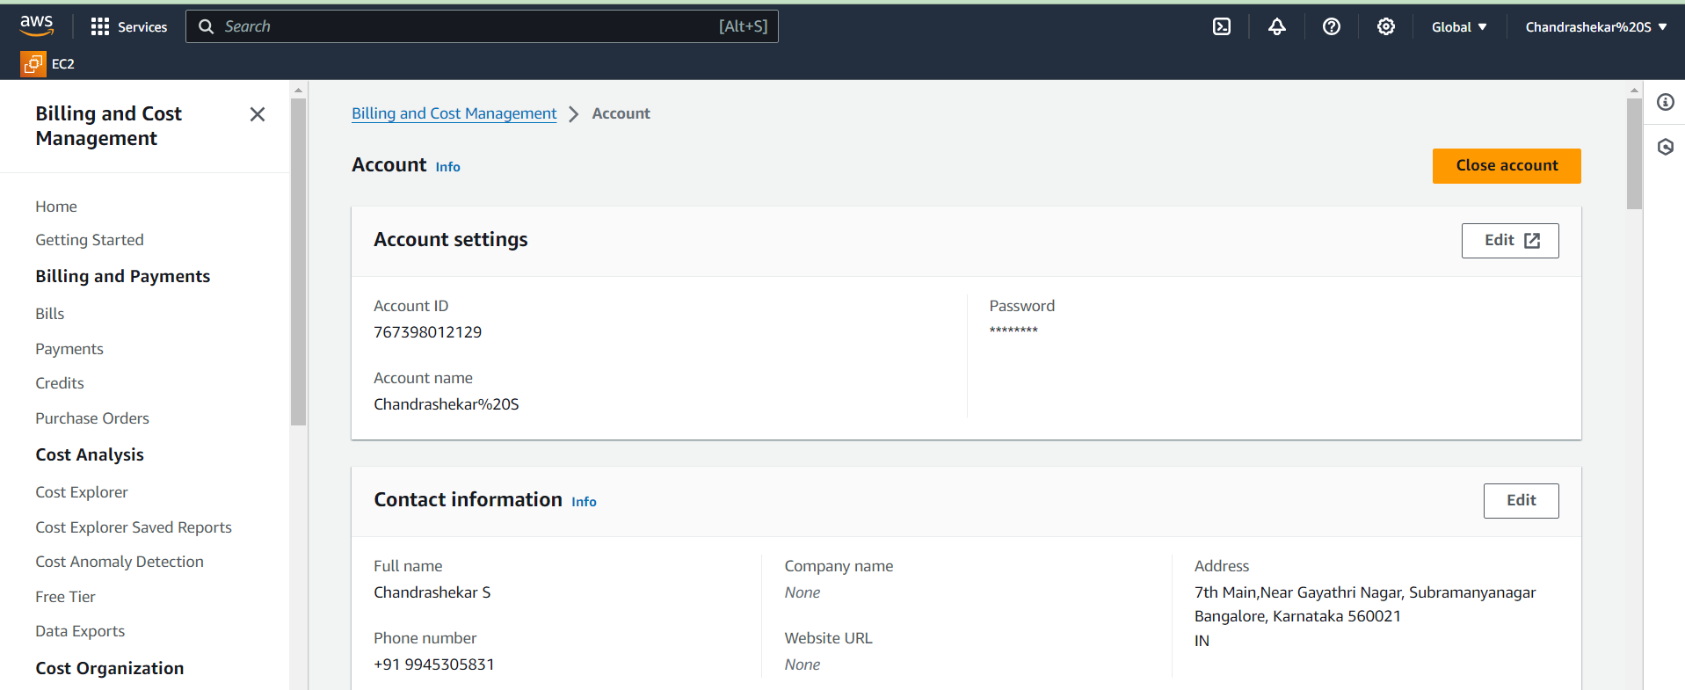

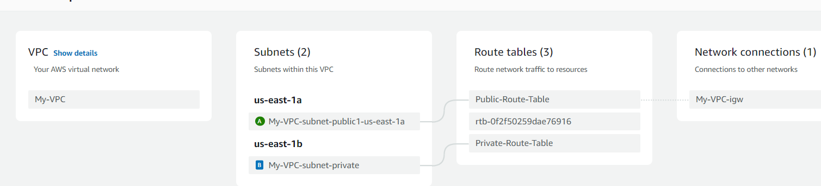

Task 2: Deploy static website on AWS S3 and upload the output of Task 1(Screen Shot) in the S3

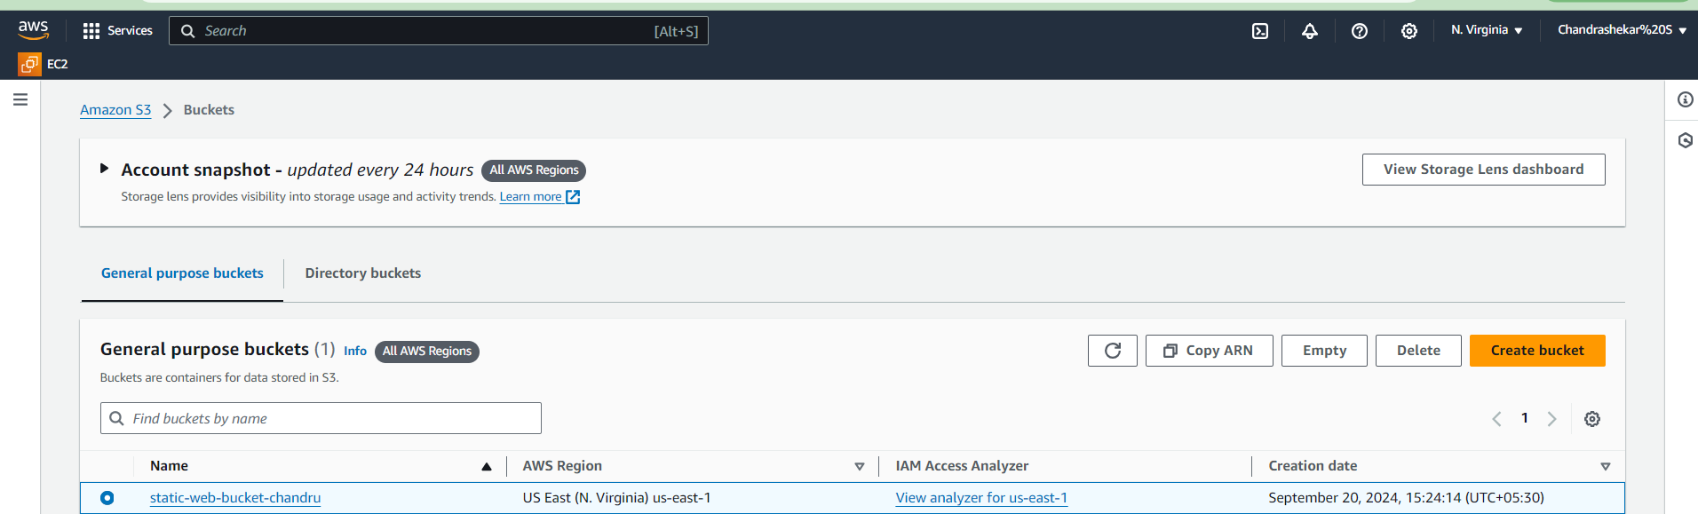

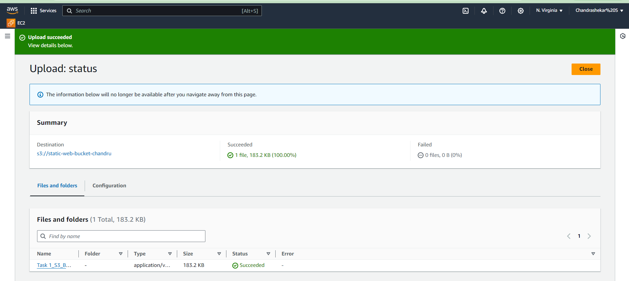

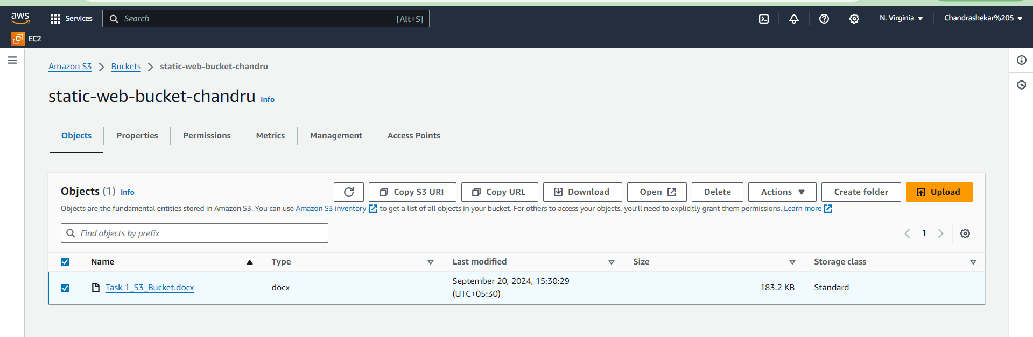

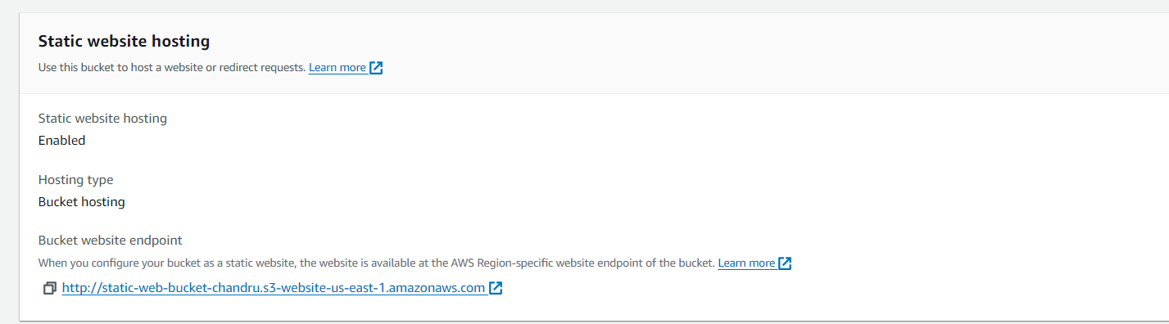

arn:aws:s3:::static-web-bucket-chandru

<https://static-web-bucket-chandru.s3.amazonaws.com/Task+1_S3_Bucket.docx>

